Declassified CIA files reveal chilling blueprint to manipulate Americans' minds through covert drugging with vaccines
By STACY LIBERATORE, US SCIENCE & TECHNOLOGY EDITOR
Published: 14:52 EST, 23 February 2026 |
Updated: 16:05 EST, 23 February 2026

A newly released CIA document reveals a chilling blueprint to manipulate minds through covert drugging experiments.
The report, added to the CIA's reading room in 2025, details the government's once top-secret Project Artichoke that ran from 1951 to 1956, focusing on behavior control, interrogation techniques and psychological manipulation.
The seven-page document, titled 'Special Research for Artichoke,' with an attachment labeled 'Suggested Fields for Special Research Relative Artichoke,' outlines proposals to develop chemicals capable of altering human behavior.
It discusses drugs designed for both immediate effects, like truth serums and long-term influence, potentially administered through food, water, alcohol or cigarettes.
Researchers also suggested that such substances could be disguised in medical treatments such as vaccinations or injections.
The CIA was also looking into methods beyond chemicals, listing hypnosis, sensory deprivation, gases and other psychological methods for interrogation and behavioral control.
Artichoke served as a precursor to the CIA's MKUltra program, which later broadened mind-altering experiments on a larger scale.
Many files were destroyed in the 1970s, leaving the full extent of the research and how far it progressed unknown.
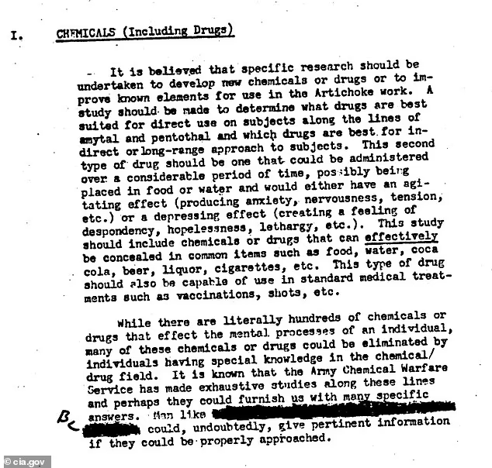
The document was declassified in 1983, but has resurfaced on social media, where users are shocked to see the CIA discussing methods for 'drugging entire populations.'
Project Artichoke emerged during the early Cold War, a period marked by intense anxiety over communist powers and reports of brainwashing techniques used on American prisoners of war in Korea.
Internal CIA memos suggested that US intelligence feared enemy nations had developed ways to control human thought and behavior, prompting the agency to explore its own capabilities.
The declassified document reveals the depth of this research, noting the need for a study 'to determine what drugs are best suited for direct use on subjects along the lines of amytal and pentothal and which drugs are best for an indirect or long-range approach to subjects.'
The researchers involved in the secret program emphasized that long-term compounds should be capable of producing 'an agitating effect (producing anxiety, nervousness, tension, etc.) or a depressing effect (creating a feeling of despondency, hopelessness, lethargy, etc.).'
They also outlined practical considerations for concealment, such as substances that could be introduced surreptitiously in 'food, water, Coca-Cola, beer, liquor, cigarettes, etc.,' highlighting the CIA's focus on undetectable methods of influence.
Moreover, the report recommended consulting with the Army Chemical Warfare Service, noting they have conducted 'exhaustive studies along these lines' that could provide specific guidance for the program.
Beyond drugs, Artichoke explored a wide range of psychological tools.
Sections of the document discussed 'hypnosis,' 'psychological techniques' and 'gases, aerosols, and oxygen deficiencies,' demonstrating that the CIA sought to combine chemical, environmental and mental approaches.
Researchers questioned whether such methods could compel individuals to perform actions against their own will, including potentially criminal acts, without leaving conscious awareness of their behavior.
Human experimentation under Artichoke often involved vulnerable subjects, including prisoners, military personnel and psychiatric patients, typically without informed consent.
While much of the documentation was destroyed in 1973, remaining files suggested that the CIA and its collaborators systematically explored the limits of psychological manipulation, with ethical considerations frequently subordinated to perceived national security needs.
Artichoke evolved into the more expansive MKUltra program in 1953, which pushed experimentation further, particularly with hallucinogens like LSD.
MKUltra involved hundreds of subprojects at universities, hospitals, and prisons, many of which used unwitting subjects, drawing outrage when the programs were exposed in the 1970s by congressional hearings, including the Church Committee.
Gangster James 'Whitey' Bulger, a former organized crime boss, was used as a test subject in 1957 while an inmate at the Atlanta penitentiary.
He explained he was one of eight convicts in a panic and paranoid state while in MKUltra.
'Total loss of appetite. Hallucinating. The room would change shape. Hours of paranoia and feeling violent,' Bulger penned.
'We experienced horrible periods of living nightmares and even blood coming out of the walls. Guys are turning into skeletons in front of me. I saw a camera change into the head of a dog. I felt like I was going insane.'

Source: https://www.dailymail.co.uk/sciencetech/article-15585657/cia-project-artichoke-mind-control.html

